HeFits App: Health and Fitness Tracking System

**Deadline: March 16, 2024**

University: Jomo Kenyatta University of Agriculture and Technology

Course: B. Sc. Computer Science

Unit: ICS 2209 Design and Implementation of Computer Applications

Group Members:

|  |  |
| --- | --- |
| Registration Number | Name |
| SCT211-0848/2018 | Jany Muong |
| SCT211-0504/2021 | Gatmach Yuol Nyuon |
| SCT211-0081/2022 | IRKE KONZOLO |
| SCT211-0085/2022 | Douglas Kimani Kitavi |
| SCT211-0011/2022 | Mike Kevin Mugambi |
| SCT211-0079/2022 | Joram Kireki |

Description

**HeFits** is a Health and Fitness Tracking System and a software solution designed to help individuals monitor and manage their health and fitness goals effectively. This system offers features to track physical activities, nutrition intake, vital signs, and overall wellness metrics. It aims to promote a healthy lifestyle by providing users with personalized insights and recommendations based on their health data. The target users include fitness enthusiasts, athletes, and individuals looking to improve their overall well-being.

Functional Requirements

1. Activity Tracking:

- Allow users to log various physical activities, such as running, cycling, or strength training.

- Provide options to track duration, distance, and calories burned for each activity session.

2. Nutrition Monitoring:

- Enable users to record their daily food intake, including meals, snacks, and beverages.

- Incorporate a database of food items with nutritional information to calculate calorie intake and macronutrient distribution.

3. Vital Signs Monitoring:

- Allow users to input vital signs data, such as heart rate, blood pressure, and body weight.

- Provide visualizations and trends analysis for vital signs to track overall health status.

4. Goal Setting and Progress Tracking:

- Enable users to set specific health and fitness goals, such as weight loss, muscle gain, or improved endurance.

- Track progress towards goals and provide motivational feedback and rewards for achievements.

5. Wellness Insights:

- Generate personalized insights and recommendations based on user data, including activity levels, nutrition habits, and vital signs.

- Offer tips and suggestions for optimizing health and fitness routines based on individual needs and preferences.

Non-Functional Requirements

1. Software Used:

- Development: Visual Studio, C#, C++, Visual Basic, a Terminal

2. Hardware Used:

This is information minimum system requirements for both server and client devices.

* Windows 10; Windows 11 works as well for a minimum;
* Storage Allocation: about 2GB

Schedule

This is the feasibility that lists out the steps that go in to the development of the app and the result of which is a deliverable. This a simple outline.

|  |  |  |
| --- | --- | --- |
| Activity | Weeks | Verbose: Deliverable/What Was Done |
| Feasibility Study | 1 | Feasibility study report completed; technical feasibility, schedule feasibility |
| Design | 1 | Interface design, Database design, Program design, Flow charts, Sequence diagram |
| Programming | 2 - 3 | Source code developed for the system; backend |
| Testing | 1 | We will assess how the program works and ascertain we don’t have bugs using a test suite. |
| Presentations | A DAY | Software and system documentation finalized, Presentation prepared |

Feasibility

This evaluates the viability of the HeFits app and its potential for successful development and implementation.

1. Technical Feasibility:

- The HeFits app requires the integration of various features such as activity tracking, nutrition monitoring, vital sign input, goal setting, and wellness insights.

- The chosen development tools, including Visual Studio and programming languages like Visual Basic, offer robust capabilities for building the app's backend infrastructure and user interface components.

2. Schedule Feasibility:

- The development timeline is outlined in the feasibility study allocating specific durations for each phase of the app's development lifecycle, including feasibility study, design, programming, testing, and is found on page 3.

3. Market Feasibility:

- The HeFits app targets a niche market of health-conscious individuals, fitness enthusiasts, athletes, and individuals seeking to improve their overall well-being.

Program Design

This segment includes the **program design** – which encompasses interface design, database design, flow charts, and sequence diagram.

Interface design

This segment visually represent the design mock-ups for the HeFits app. Have a look below.

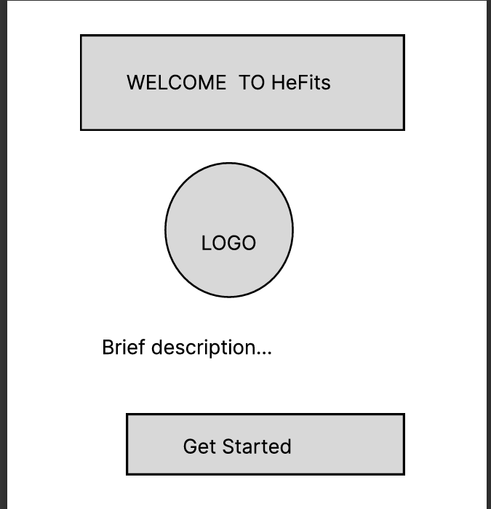

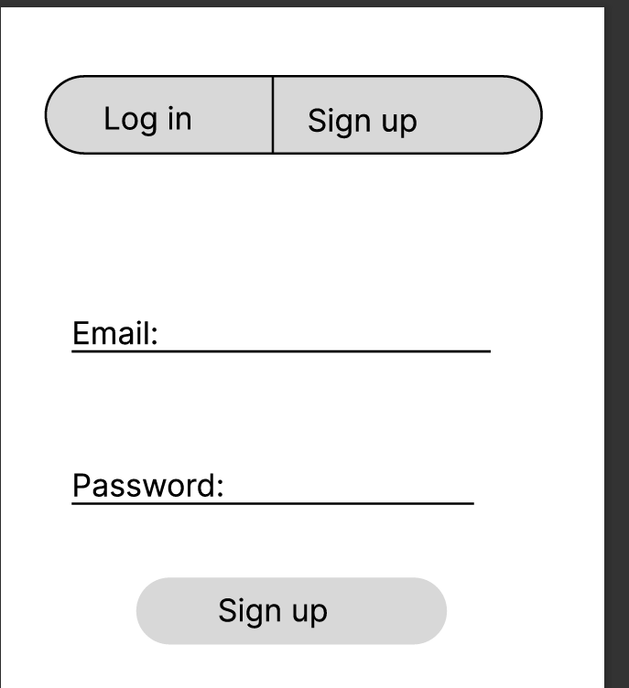

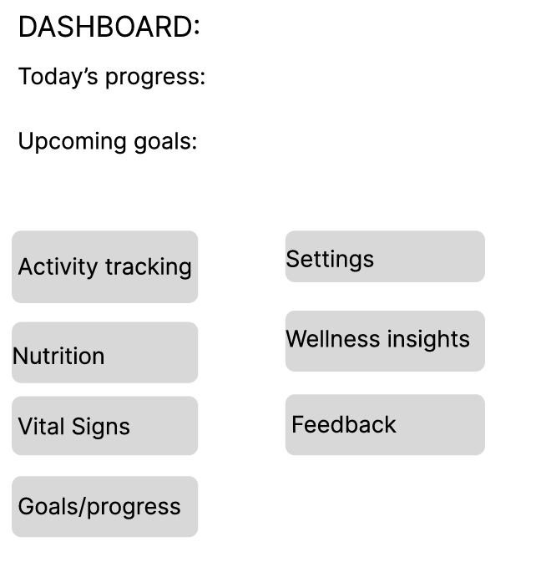

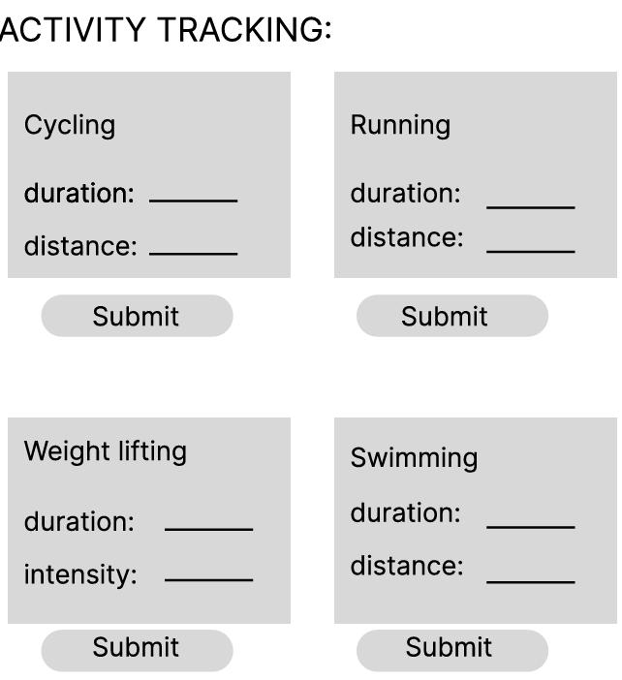

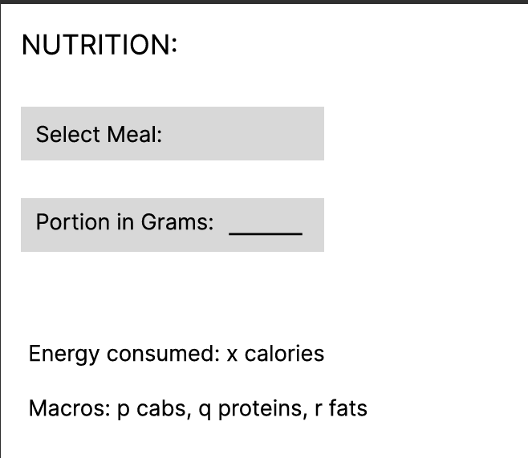

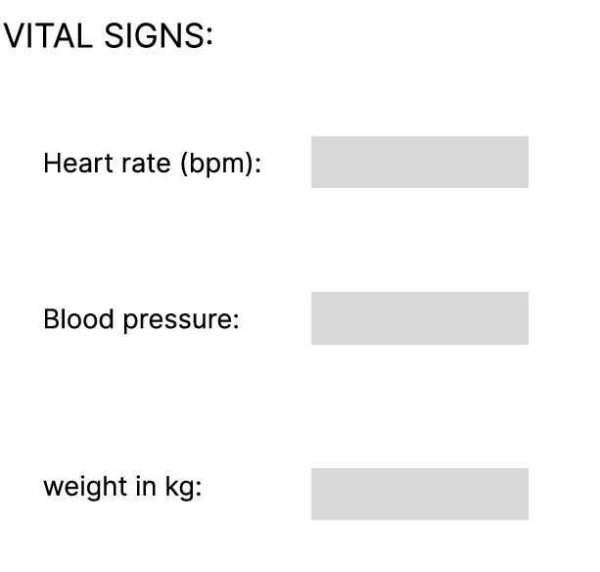

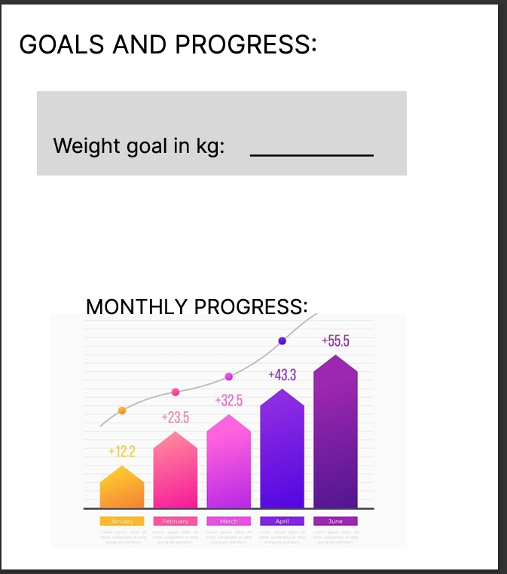

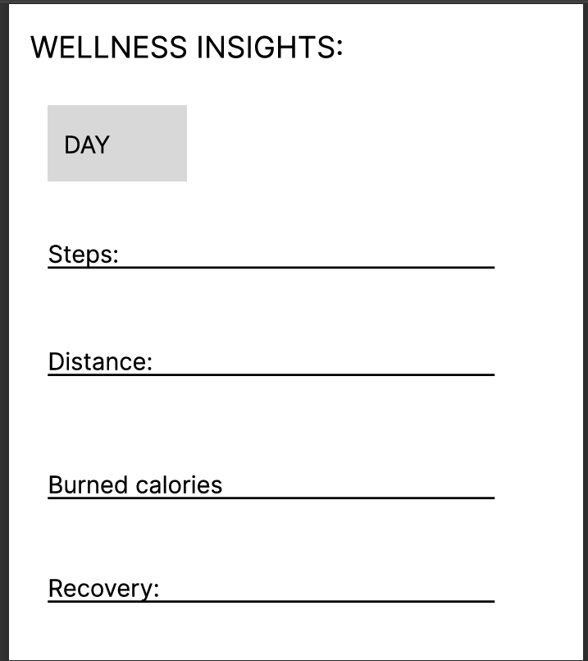

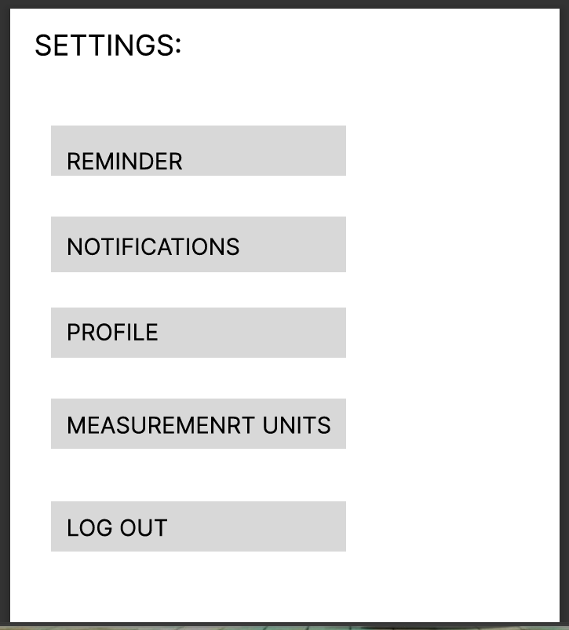

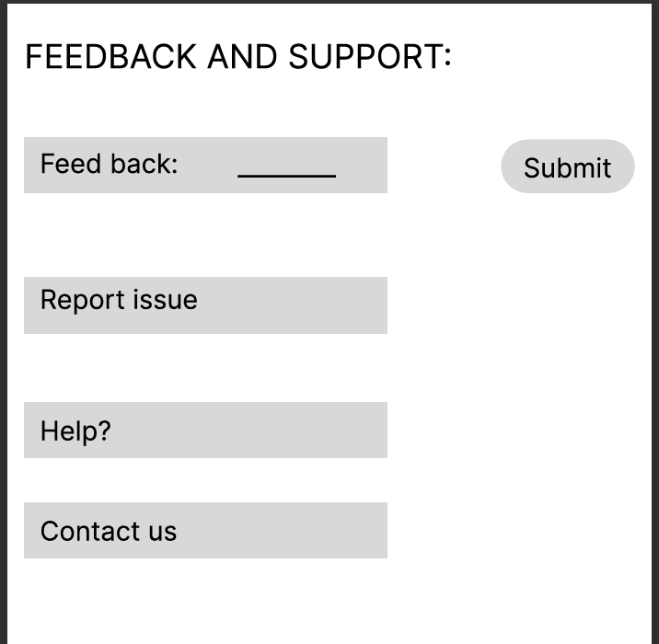

Database Design

This section encompasses the entities and /or tables of the HeFits application in terms of the schema.

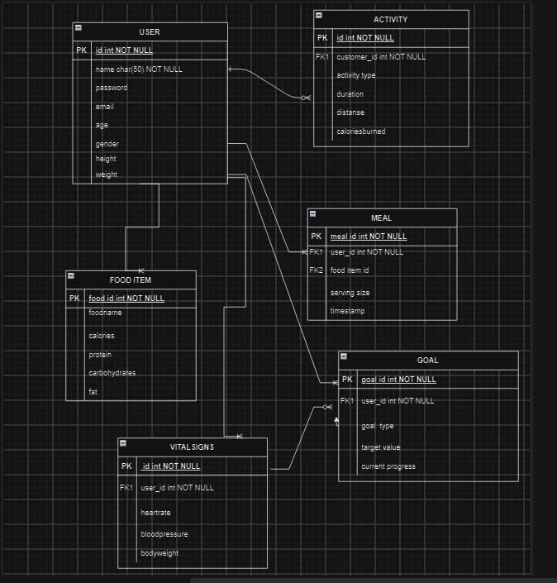

Flow Chart

This section summarizes how the app works visually. It outlines the logical flow of operations within the application: including activity tracking, nutrition monitoring, vital sign input, goal setting, and wellness insights. Each functionality is represented by a series of interconnected nodes and decision points, illustrating the sequential steps a user follows to accomplish tasks within the app. The flowchart abstractly demonstrates how users interact with different components of the HeFits app, such as logging activities, recording nutrition, inputting vital signs, and setting health goals.

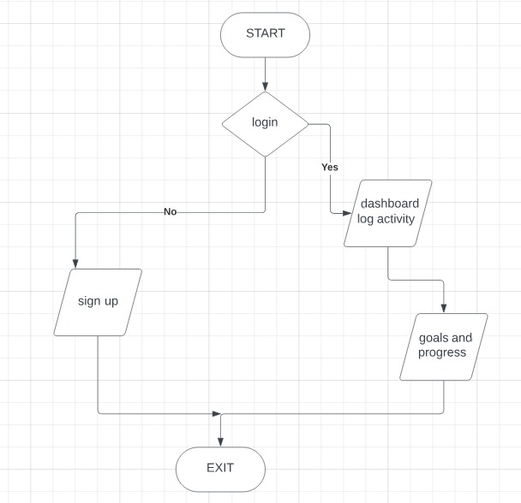

Sequence diagram

This diagram visually represents the flow of messages or interactions between the user and different components (ActivityLog, NutritionRecord, VitalSignEntry, HealthGoal) of the **HeFits** App, as well as interactions between these components and the database. Each arrow represents a message being sent from one participant to another, indicating the flow of communication. The labels on the arrows describe the specific actions being performed, such as logging activity, recording nutrition, etc. The dashed arrows represent the confirmation messages sent from the Database back to the respective components after successfully saving the data.

